CNN

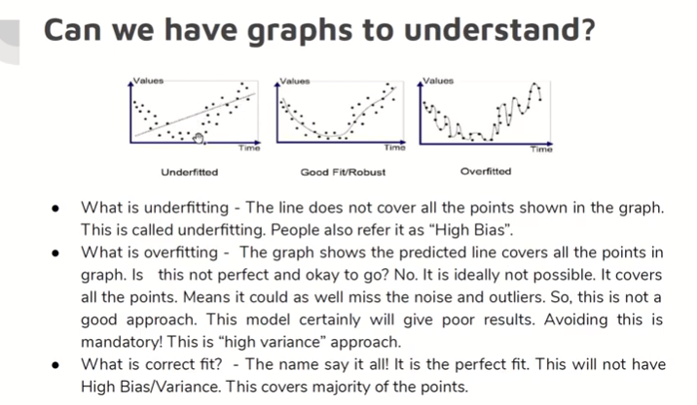

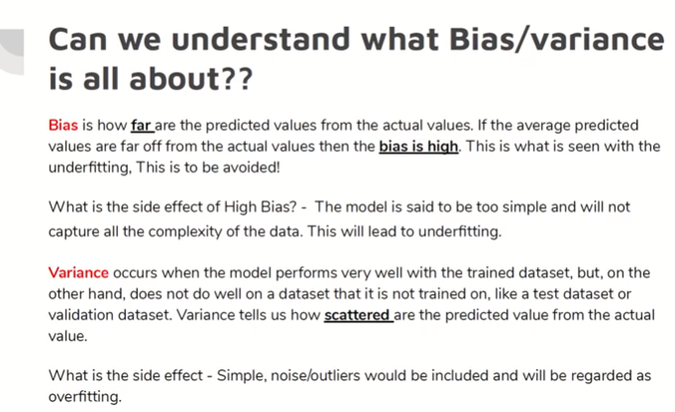

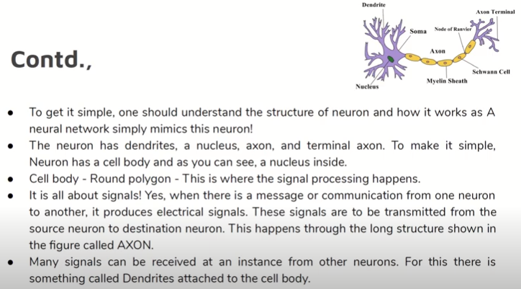

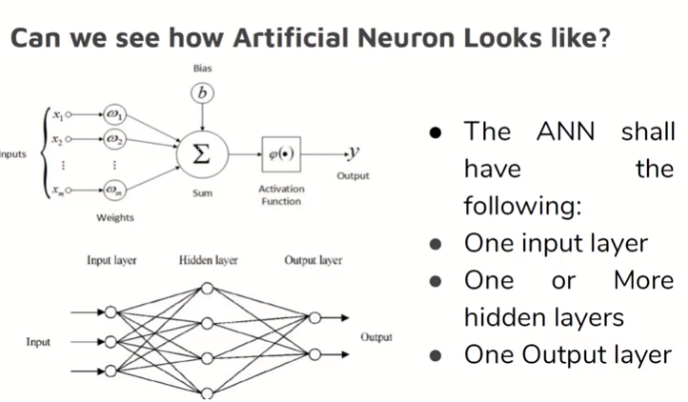

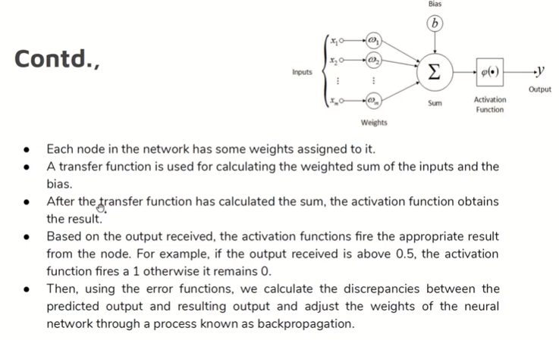

CNN

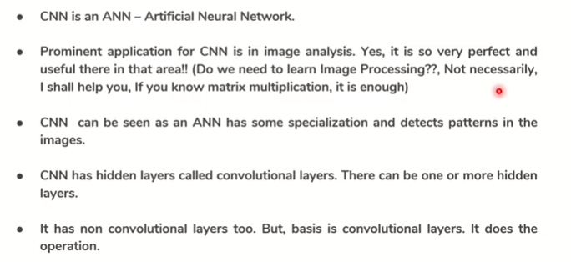

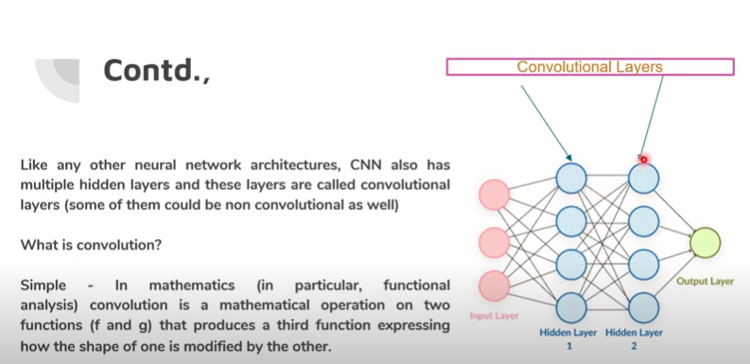

* Convolutional Neural Network (CNN) are designed to address image recognition systems and classification problems. Convolutional Neural Networks have wide applications in image and video recognition, recommendation systems and natural language processing.

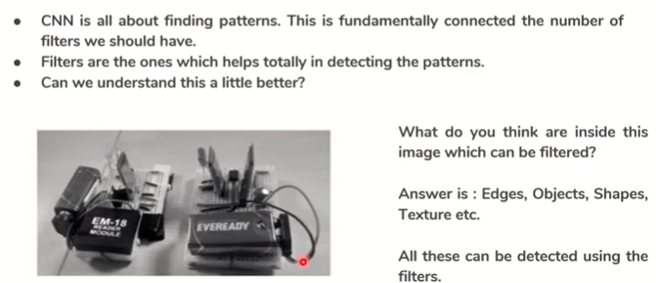

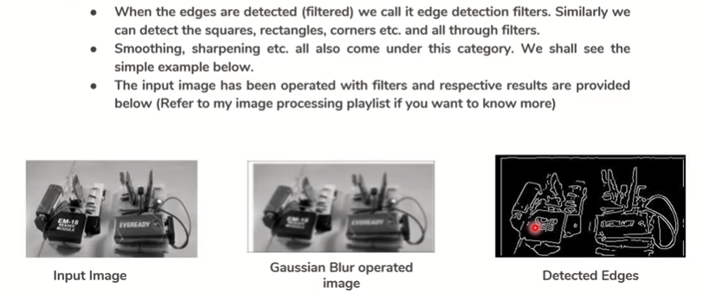

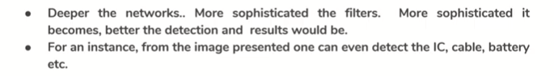

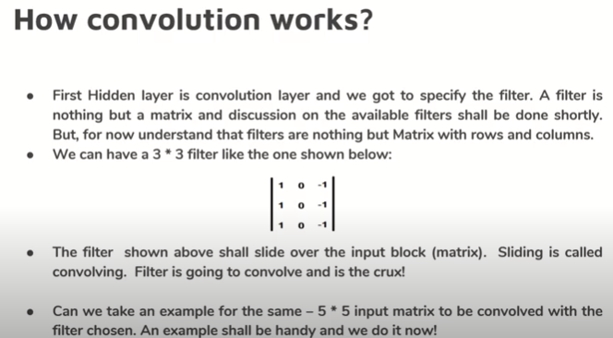

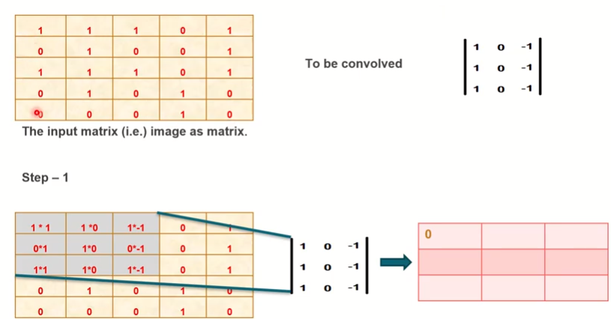

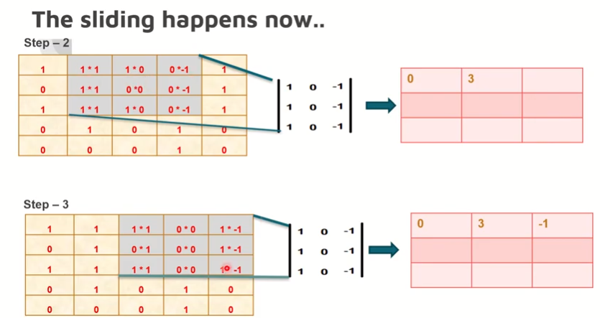

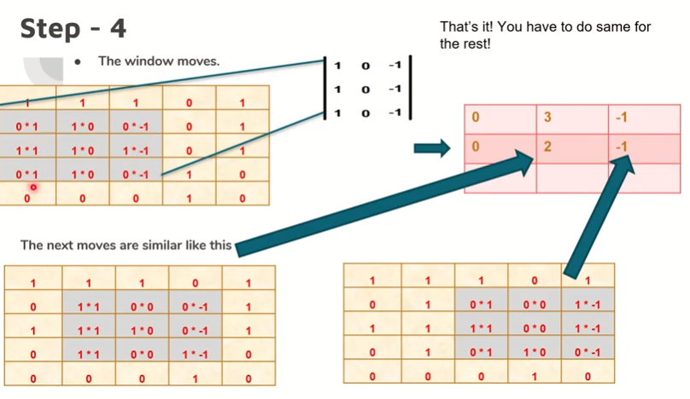

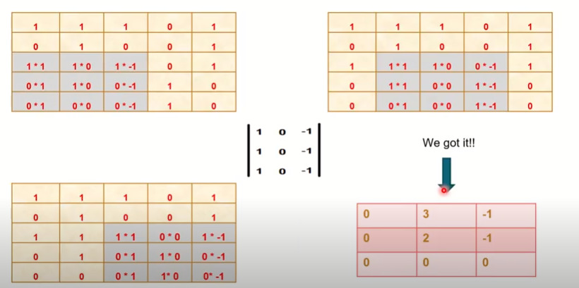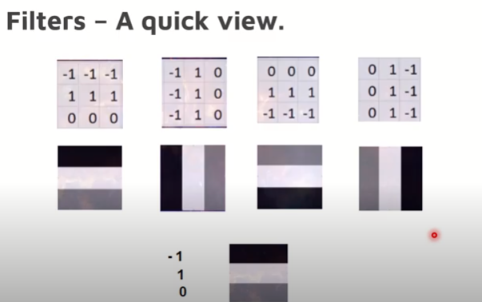

How Does A Computer Read an Image?

* Consider this image of the New York skyline, upon first glance you will see a lot of buildings and colors. So how does the computer process this image?
* 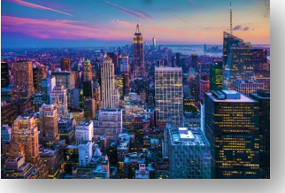
* The image is broken down into 3 color-channels which is Red, Green and Blue. Each of these color channels are mapped to the image’s pixel.
* 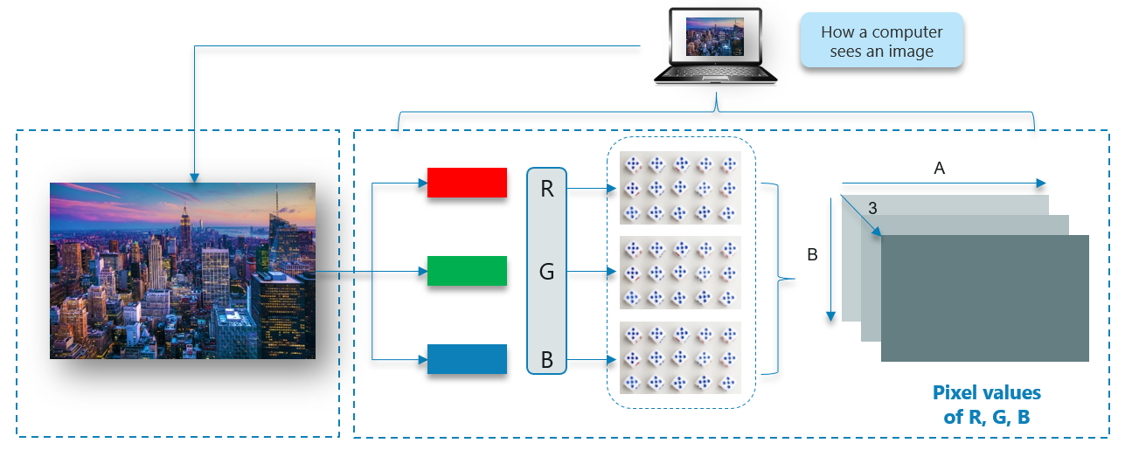  
  Then, the computer recognizes the values associated with each pixel and determine the size of the image.
* Size of the image B*A*3 then it has B rows, B columns, 3 channels
* However, for black-white images, there is only one channel and the concept is the same.

Why Not Fully Connected Networks for Image Classification?

We cannot make use of fully connected networks when it comes to Convolutional Neural Networks, here’s why!

Consider the following image: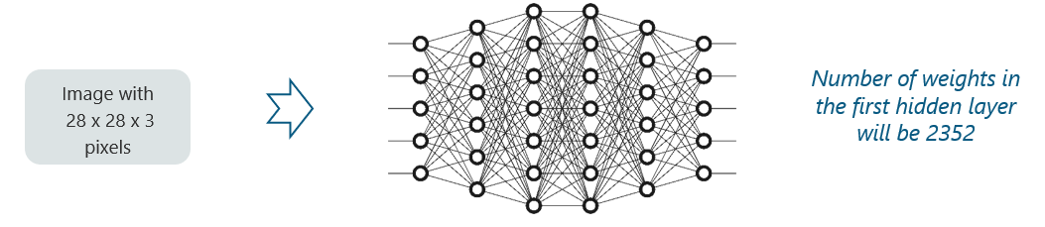

Here, we have considered an input of images with the size 28x28x3 pixels. If we input this to our Convolutional Neural Network, we will have about 2352 weights in the first hidden layer itself(28*28*3=2352).

## Convolutional Neural Networks 2

Any generic input image will at least have 200x200x3 pixels in size. The size of the first hidden layer becomes a whooping 120,000. If this is just the first hidden layer, imagine the number of neurons needed to process an entire complex image-set.

This leads to over-fitting and isn’t practical. Hence, we cannot make use of fully connected networks.

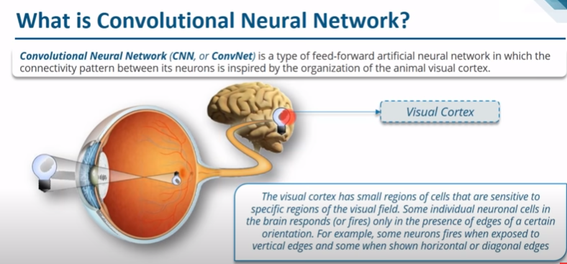

What Are Convolutional Neural Networks?

Convolutional Neural Networks, like neural networks, are made up of neurons with learnable weights and biases. Each neuron receives several inputs, takes a weighted sum over them, pass it through an activation function and responds with an output.

The whole network has a loss function and all the tips and tricks that we developed for neural networks still apply on Convolutional Neural Networks.

Neural networks, as its name suggests, is a machine learning technique which is modeled after the brain structure. It comprises of a network of learning units called neurons.

These neurons learn how to convert input signals (e.g. picture of a cat) into corresponding output signals (e.g. the label “cat”), forming the basis of automated recognition.

Let’s take the example of automatic image recognition. The process of determining whether a picture contains a cat involves an activation function. If the picture resembles prior cat images the neurons have seen before, the label “cat” would be activated.

Hence, the more labeled images the neurons are exposed to, the better it learns how to recognize other unlabelled images. We call this the process of training neurons.

How Do Convolutional Neural Networks Work?

There are four layered concepts we should understand in Convolutional Neural Networks:

1. Convolution,
2. ReLu Layer
3. Pooling
4. Full Connectedness (Fully Connected Layer).

Let’s begin by checking out a simple example:

Example of CNN:

Consider the image below:

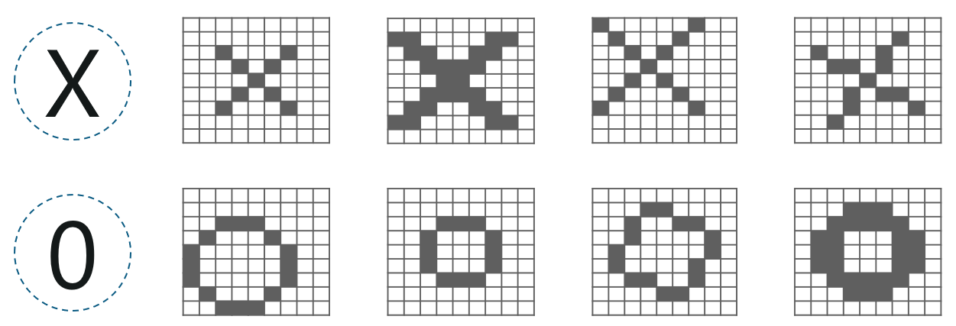

Here, there are multiple renditions of X and O’s. This makes it tricky for the computer to recognize. But the goal is that if the input signal looks like previous images it has seen before, the “image” reference signal will be mixed into, or convolved with, the input signal. The resulting output signal is then passed on to the next layer.

**How CNN Works??**

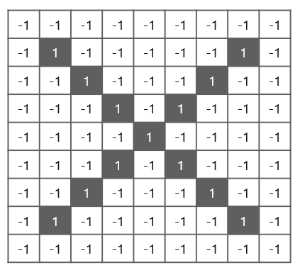

So, the computer understands every pixel. In this case, the white pixels are said to be -1 while the black ones are 1. This is just the way we’ve implemented to differentiate the pixels in a basic binary classification.

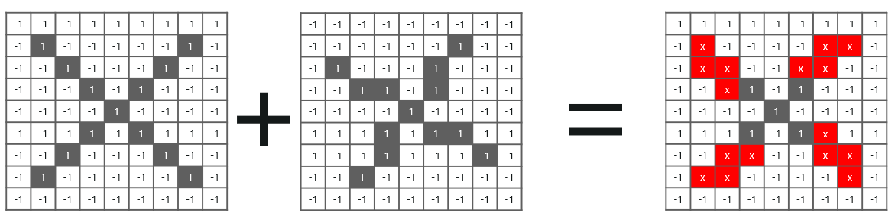

Now if we would just normally search and compare the values between a normal image and another ‘x’ rendition, we would get a lot of missing pixels.

**So, how do we fix this?**

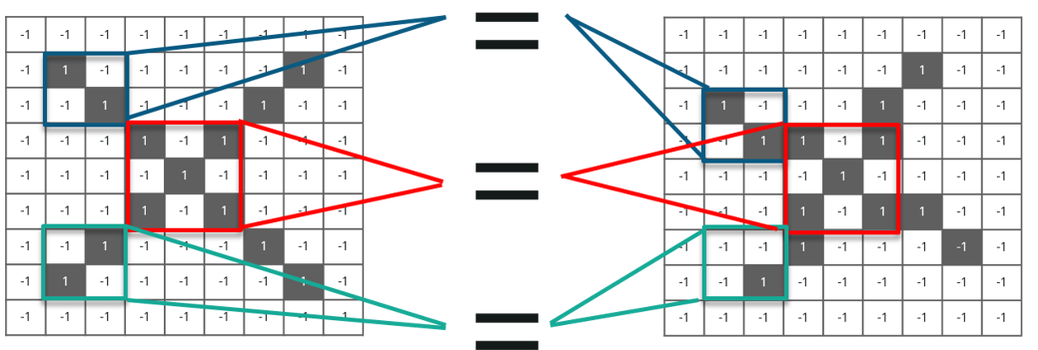

We take small patches of the pixels called filters and try to match them in the corresponding nearby locations to see if we get a match. By doing this, the Convolutional Neural Network gets a lot better at seeing similarity than directly trying to match the entire image.

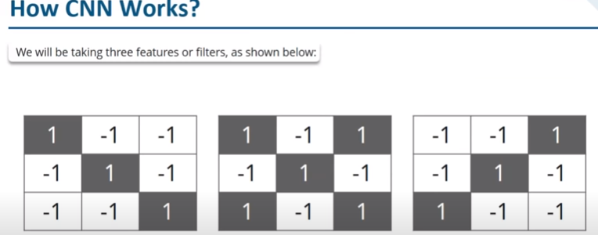

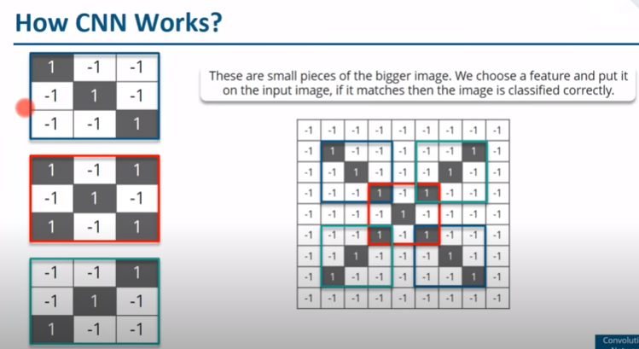

Convolution Of An Image

Convolution has the nice property of being translational invariant. Intuitively, this means that each convolution filter represents a feature of interest (e.g pixels in letters) and the Convolutional Neural Network algorithm learns which features comprise the resulting reference (i.e. alphabet).

We have 4 steps for convolution:

* Line up the feature and the image
* Multiply each image pixel by corresponding feature pixel
* Add the values and find the sum
* Divide the sum by the total number of pixels in the feature

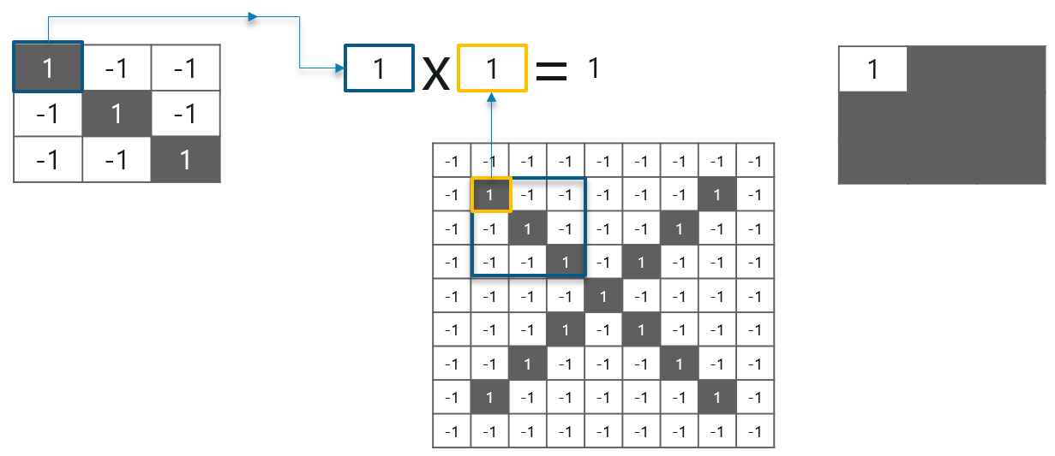

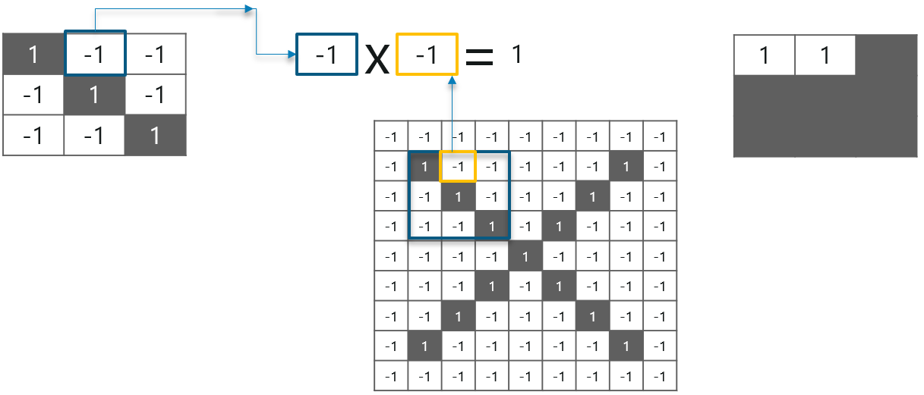

Consider the above image – As you can see, we are done with the first 2 steps. We considered a feature image and one pixel from it. We multiplied this with the existing image and the product is stored in another buffer feature image.

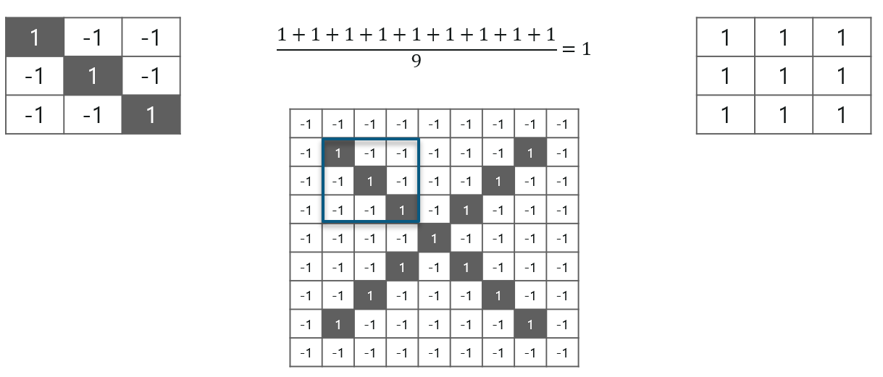

With this image, we completed the last 2 steps. We added the values which led to the sum. We then, divide this number by the total number of pixels in the feature image. When that is done, the final value obtained is placed at the center of the filtered image as shown below:

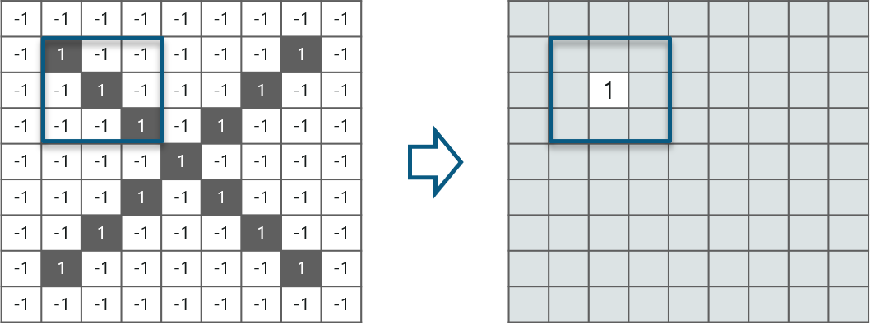

 Now, we can move this filter around and do the same at any pixel in the image. For better clarity, let’s consider another example:

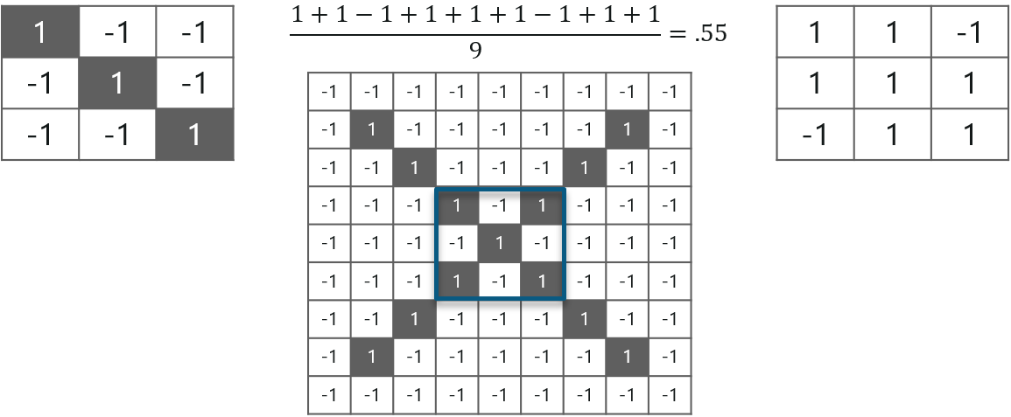

As you can see, here after performing the first 4 steps we have the value at 0.55! We take this value and place it in the image as explained before. This is done in the following image:

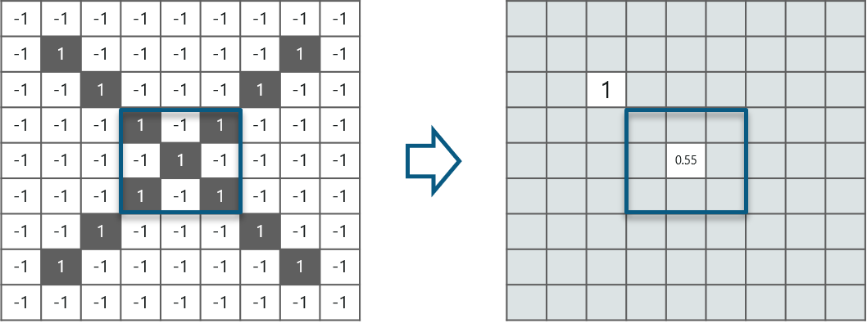

Similarly, we move the feature to every other position in the image and see how the feature matches that area. So after doing this, we will get the output as:

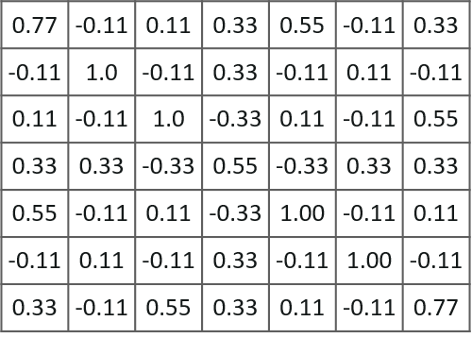

Similarly, we will perform the same convolution with every other filter to get the convolution of that filter.

After performing the filter operation with other 2 feature we will get the output like this.

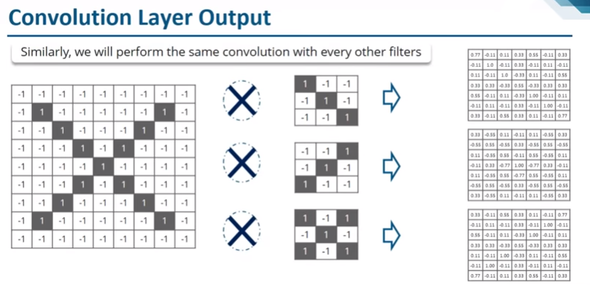

The output signal strength is not dependent on where the features are located, but simply whether the features are present. Hence, an alphabet could be sitting in different positions and the Convolutional Neural Network algorithm would still be able to recognize it.

Extra----2

This is the first step in the process of extracting valuable features from an image. A convolution layer has several filters that perform the convolution operation. Every image is considered as a matrix of pixel values.

Consider the following 5x5 image whose pixel values are either 0 or 1. There’s also a filter matrix with a dimension of 3x3. Slide the filter matrix over the image and compute the dot product to get the convolved feature matrix.

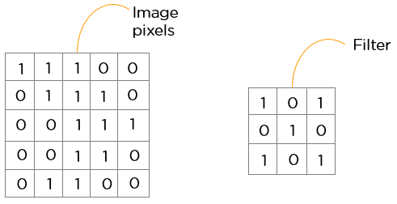

**ReLU Layer**

ReLU is an activation function. But, what is an activation function?

Rectified Linear Unit (ReLU) transform relationship with the dependent variable.

Consider the below example function only activates a node if the input is above a certain quantity, while the input is below zero, the output is zero, but when the input rises above a certain threshold, it has a linear:

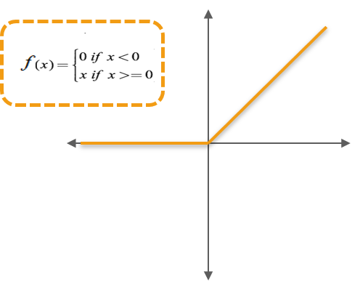

We have considered a simple function with the values as mentioned above. So the function only performs an operation if that value is obtained by the dependent variable. For this example, the following values are obtained:

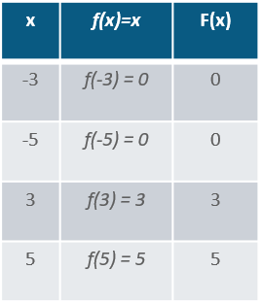

**Why do we require ReLU here?**

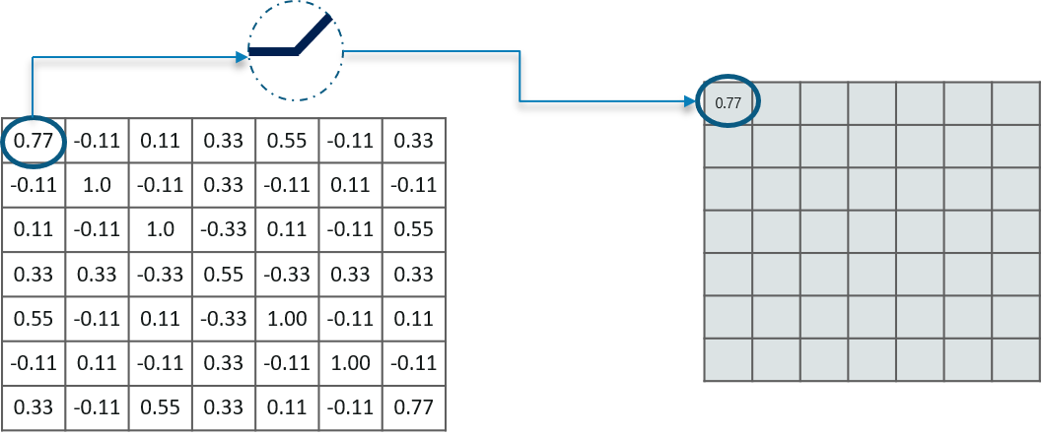

The main aim is to remove all the negative values from the convolution (RELU will remove all –ve value). All the positive values remain the same but all the negative values get changed to zero as shown below:

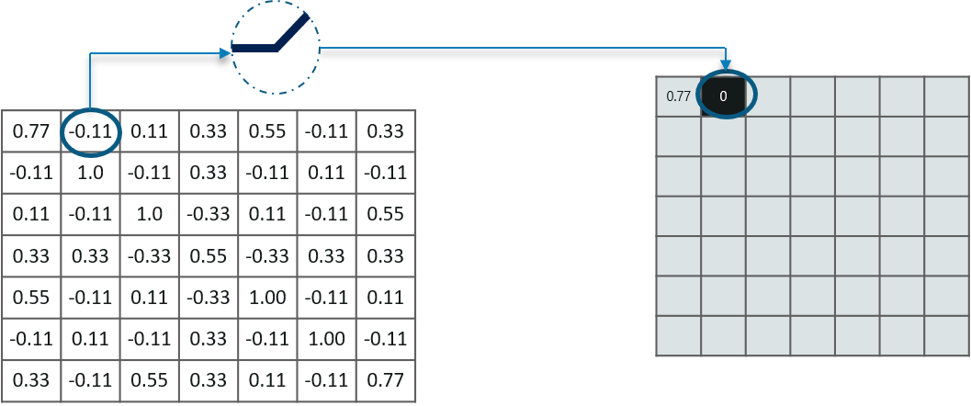

So after we process this particular feature we get the following output:

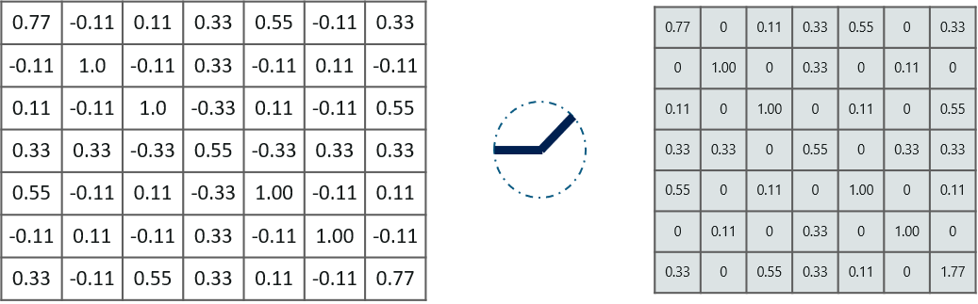

Now, similarly we do the same process to all the other feature images as well:

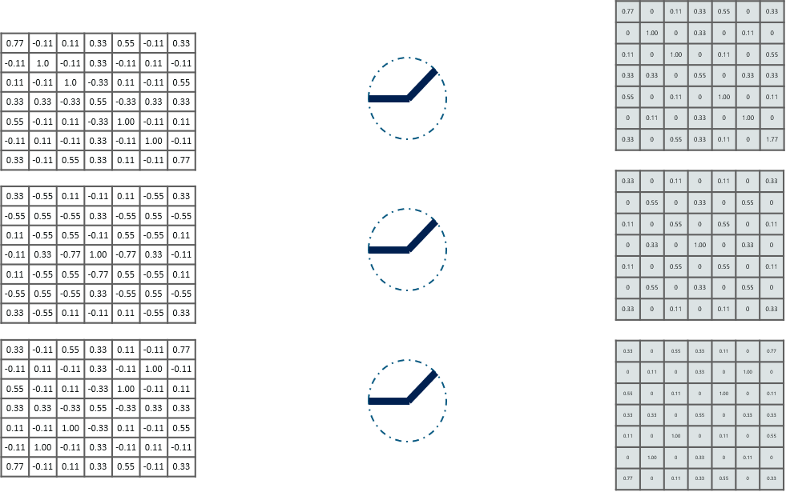

Inputs from the convolution layer can be “smoothened” to reduce the sensitivity of the filters to noise and variations. This smoothing process is called sub sampling and can be achieved by taking averages or taking the maximum over a sample of the signal.

Extra:

ReLU stands for the rectified linear unit. Once the feature maps are extracted, the next step is to move them to a ReLU layer.

ReLU performs an element-wise operation and sets all the negative pixels to 0. It introduces non-linearity to the network, and the generated output is a rectified feature map. Below is the graph of a ReLU function:

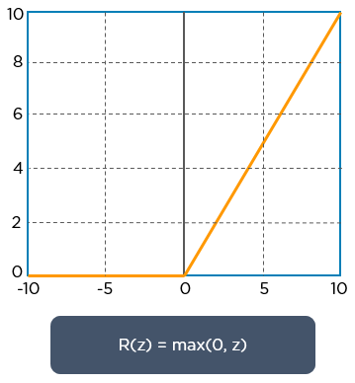

**Pooling Layer**

In this layer we shrink the image stack into a smaller size. Pooling is done after passing through the activation layer. We do this by implementing the following 4 steps:

* Pick a window size (usually 2 or 3)
* Pick a stride (usually 2)
* Walk your window across your filtered images
* From each window, take the maximum value

Let us understand this with an example. Consider performing pooling with a window size of 2 and stride being 2 as well.

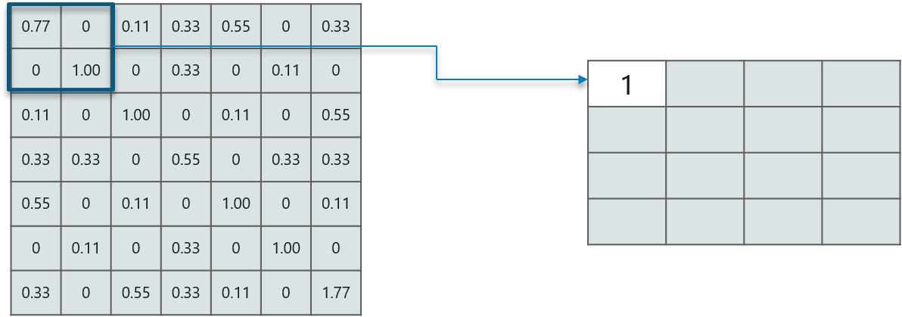

So in this case, we took window size to be 2 and we got 4 values to choose from. From those 4 values, the maximum value there is 1 so we pick 1. Also, note that we started out with a 7×7 matrix but now the same matrix after pooling came down to 4×4.

But we need to move the window across the entire image. The procedure is exactly as same as above and we need to repeat that for the entire image.

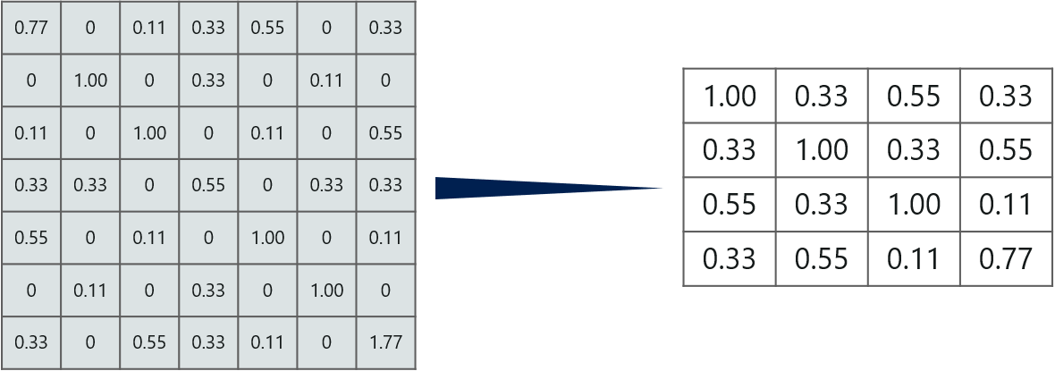

Do note that this is for one filter. We need to do it for 2 other filters as well. This is done and we arrive at the following result:

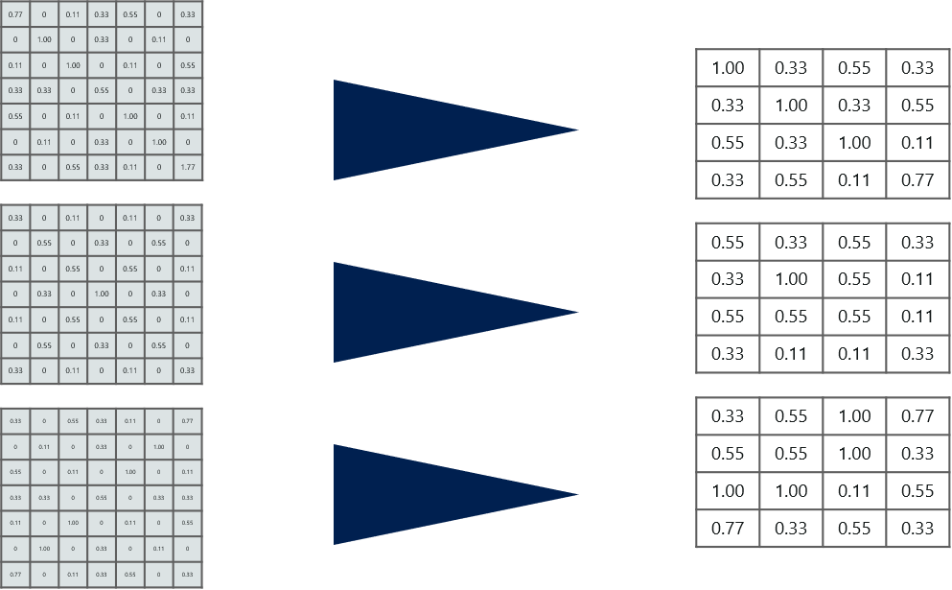

Well the easy part of this process is over. Next up, we need to stack up all these layers!

Extra:

Pooling is a down-sampling operation that reduces the dimensionality of the feature map. The rectified feature map now goes through a pooling layer to generate a pooled feature map.

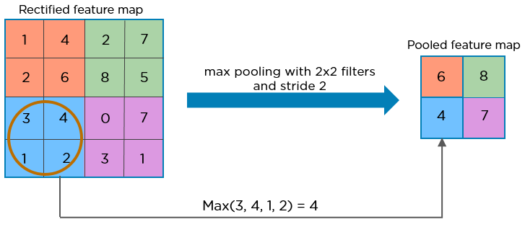

The pooling layer uses various filters to identify different parts of the image like edges, corners, body, feathers, eyes, and beak.

**Stacking Up The Layers**

So to get the time-frame in one picture we’re here with a 4×4 matrix from a 7×7 matrix after passing the input through 3 layers – Convolution, ReLU and Pooling as shown below:

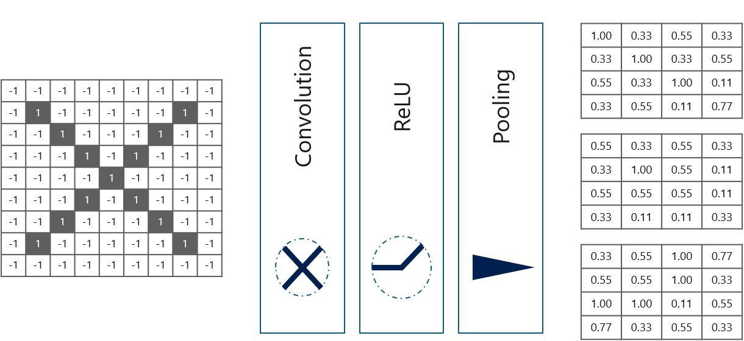

But can we further reduce the image from 4×4 to something lesser?

Yes, we can! We need to perform the 3 operations in an iteration after the first pass. So after the second pass we arrive at a 2×2 matrix as shown below:

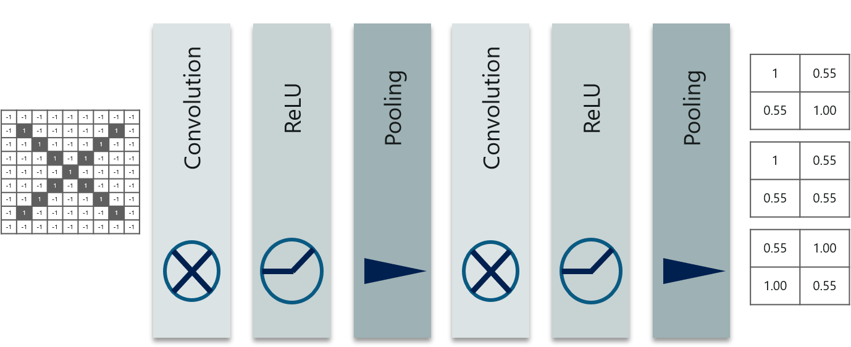

The last layers in the network are fully connected, meaning that neurons of preceding layers are connected to every neuron in subsequent layers.

This mimics high level reasoning where all possible pathways from the input to output are considered.

**Fully Connected Layer/Flattening**

Fully connected layer is the final layer where the classification actually happens. Here we take our filtered and shrinked images and put them into one single list as shown below:

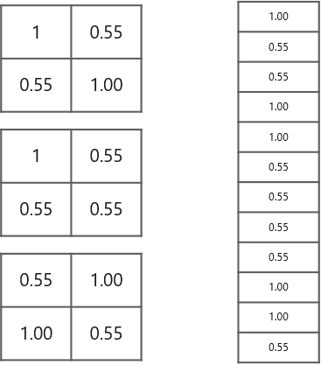

So next, when we feed in, ‘X’ and ‘O’ there will be some element in the vector that will be high. Consider the image below, as you can see for ‘X’ there are different elements that are high and similarly, for ‘O’ we have different elements that are high:

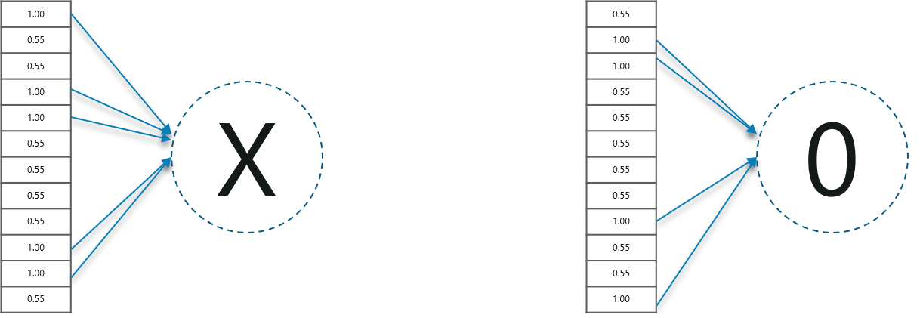

Well, what did we understand from the above image?

When the 1st, 4th, 5th, 10th and 11th values are high, we can classify the image as ‘x’. The concept is similar for the other alphabets as well – when certain values are arranged the way they are, they can be mapped to an actual letter or a number which we require, simple right?

Prediction Of Image Using Convolutional Neural Networks – Fully Connected Layer

At this point in time, we’re done training the network and we can begin to predict and check the working of the classifier. Let’s check out a simple example:

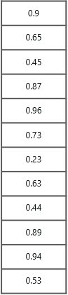

We have a 12 element vector obtained after passing the input of a random letter through all the layers of our network.

But, how do we check to know what we’ve obtained is right or wrong?

We **make predictions** based on the **output** data by comparing the **obtained values** with list of ‘x’and ‘o’!

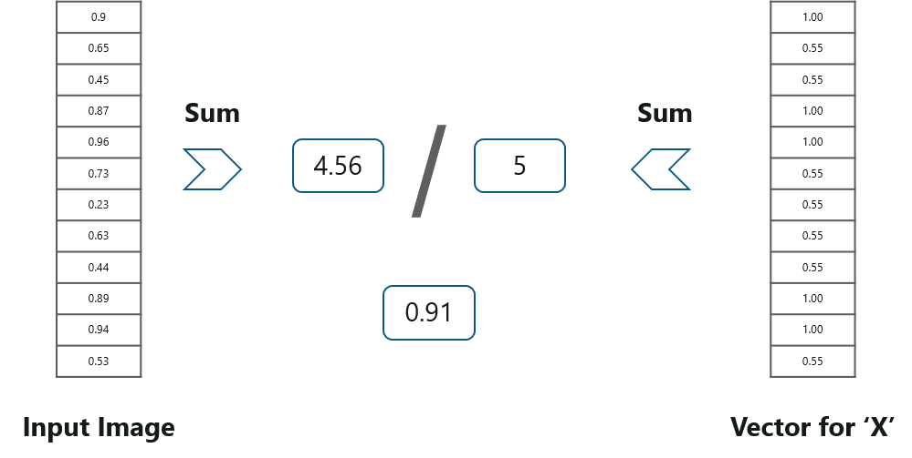

Well, it is really easy. We just added the values we which found out as high (1st, 4th, 5th, 10th and 11th) from the vector table of X and we got the sum to be 5. We did the exact same thing with the input image and got a value of 4.56.

When we divide the value we have a probability match to be 0.91! Let’s do the same with the vector table of ‘o’ now:

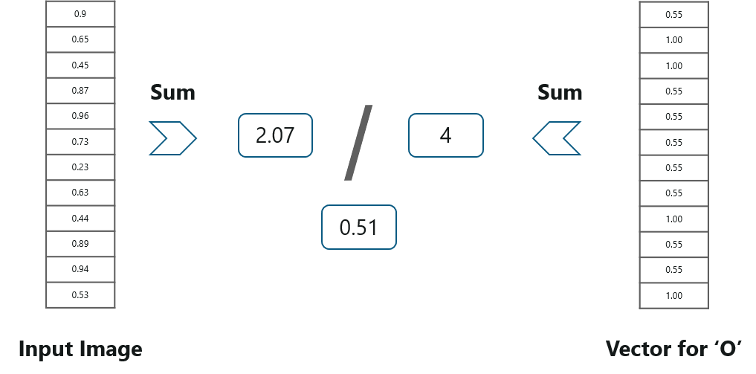

We have the output as 0.51 with this table. Well, probability being 0.51 is less than 0.91, isn’t it?

So we can conclude that the resulting input image is an ‘x’!

Extra:

Flattening is used to convert all the resultant 2-Dimensional arrays from pooled feature maps into a single long continuous linear vector.

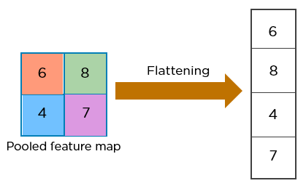

The flattened matrix is fed as input to the fully connected layer to classify the image.

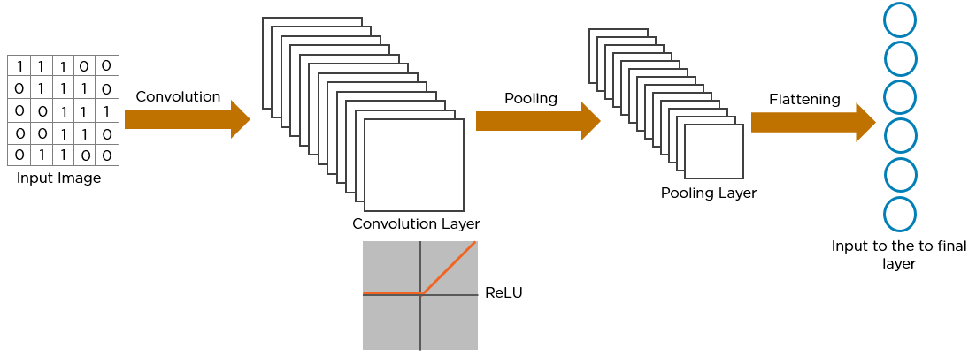

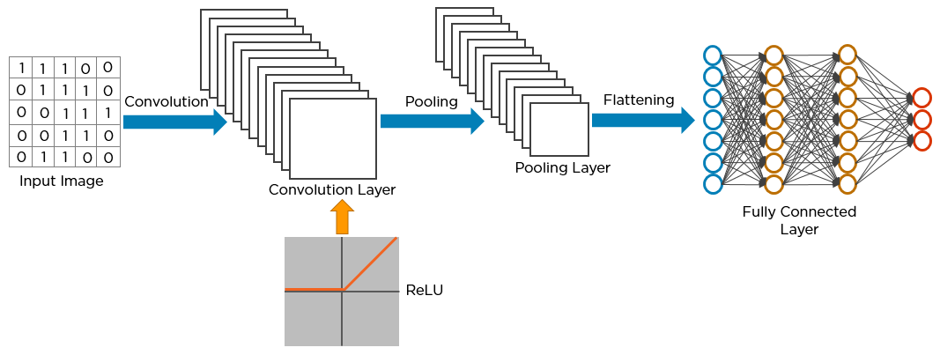

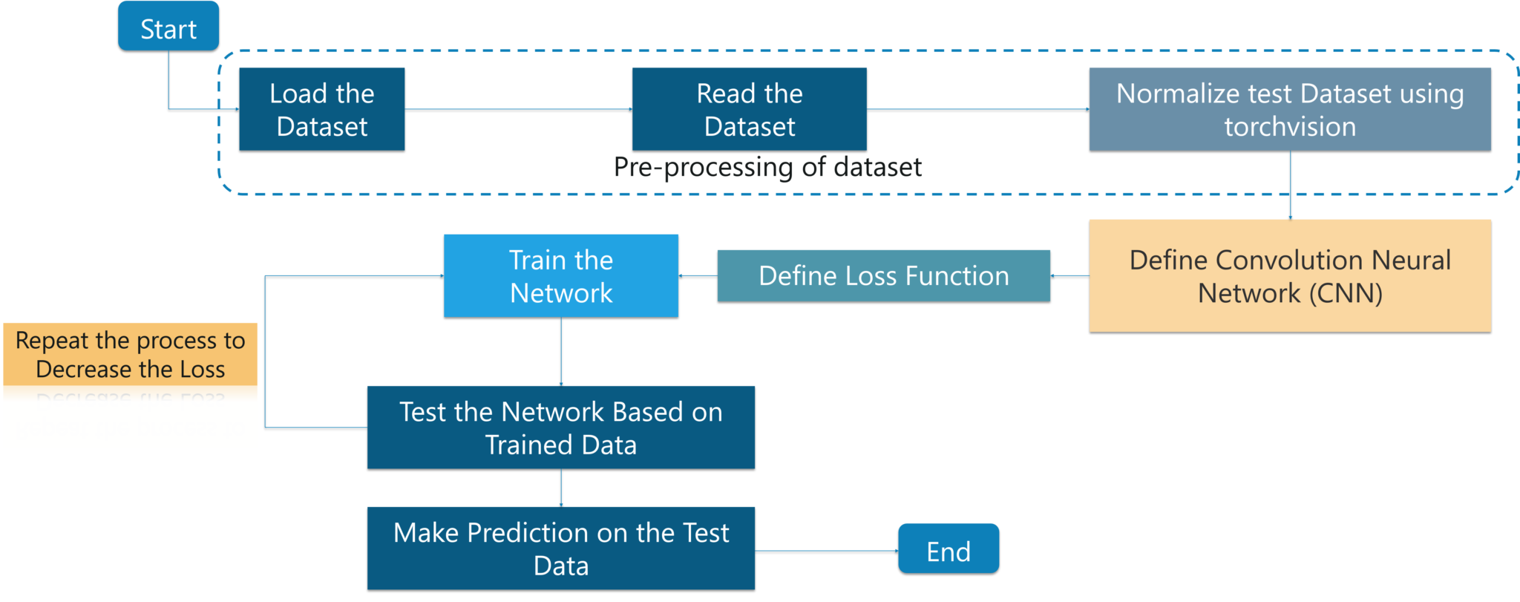

Here’s how exactly CNN recognizes a bird:

* The pixels from the image are fed to the convolutional layer that performs the convolution operation
* It results in a convolved map
* The convolved map is applied to a ReLU function to generate a rectified feature map
* The image is processed with multiple convolutions and ReLU layers for locating the features
* Different pooling layers with various filters are used to identify specific parts of the image
* The pooled feature map is flattened and fed to a fully connected layer to get the final output

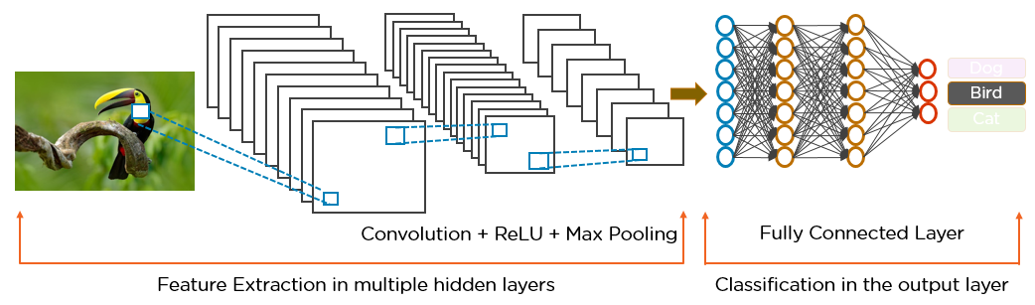

**Feature Maps**

**Zero Padding**

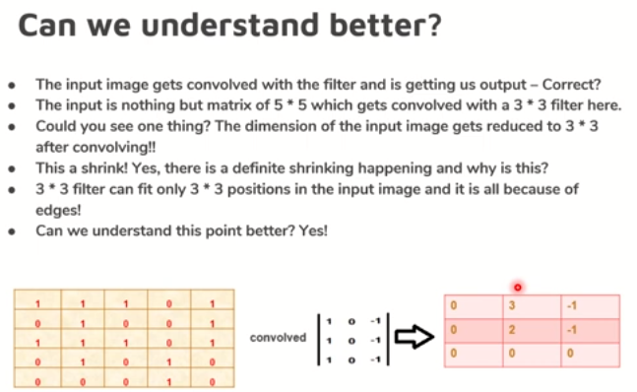

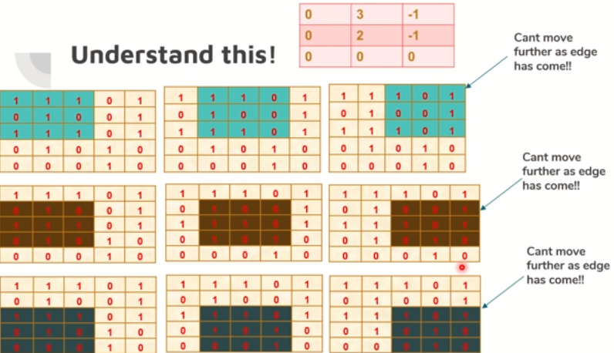

Because of this edges we can’t move further.

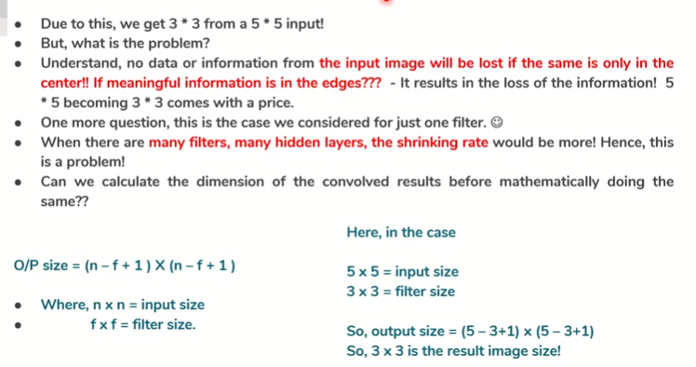

When there is no important information available on edges/corner of the images there is no problem. But, if there is important information is available & if we convolve it further & further, the important information could be lost. No data from the input image will lost if the same will be with center/ if the pattern is in the center of the matrix , don’t have problem while cutting the edges/shrinking the matrix.

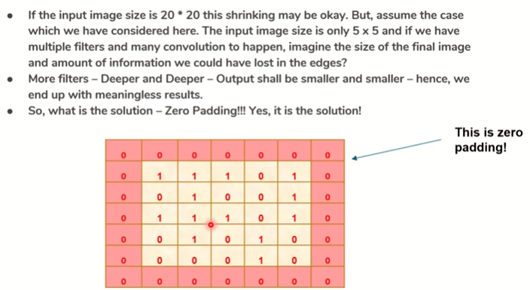

20*20 shrinking to 15*15 its ok. But shrinking to 5*5 is meaningless. It can create a problem when we are working with input matrix of small size.

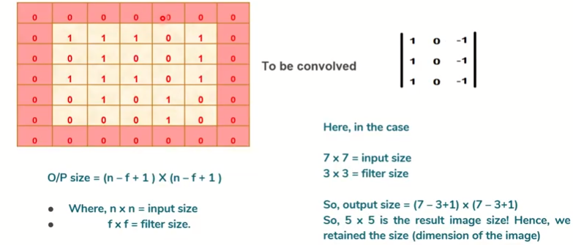

The i/p 5*5 matrix & o/p also able to retain as 5*5. Here the dimension are not hampered.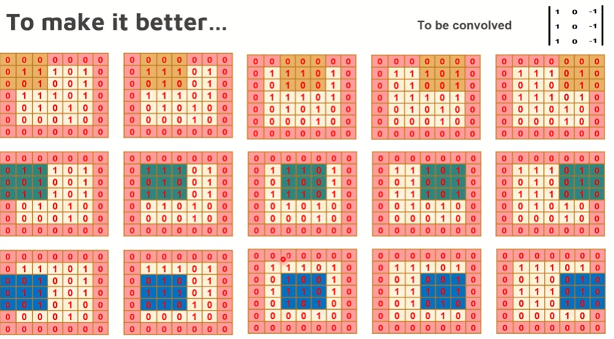

We could retain the dimensions of the input image through zero padding. We can have 2/3 layer of zero padding.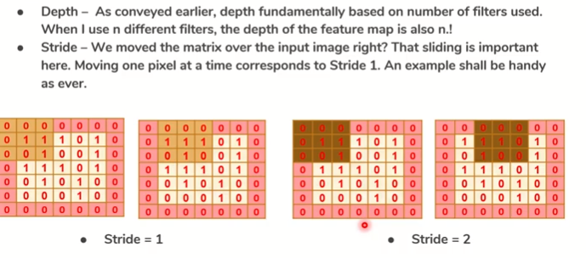

If we move 2 pixel away then we called stride as 2.

**Max Pooling, Average Pooling, Sum Pooling**

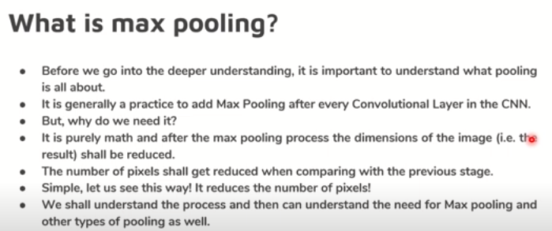

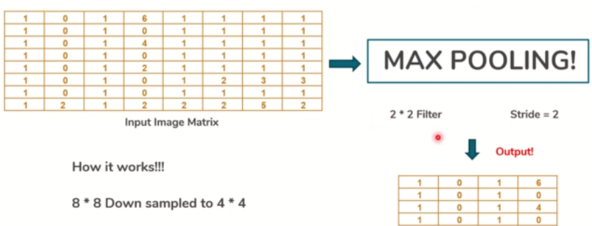

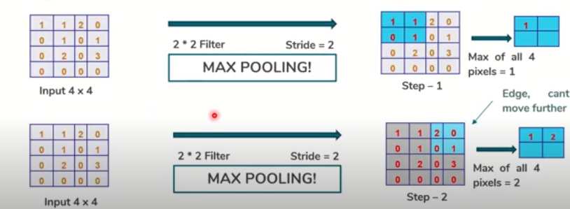

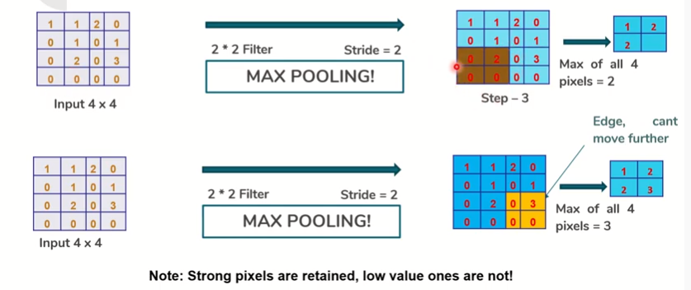

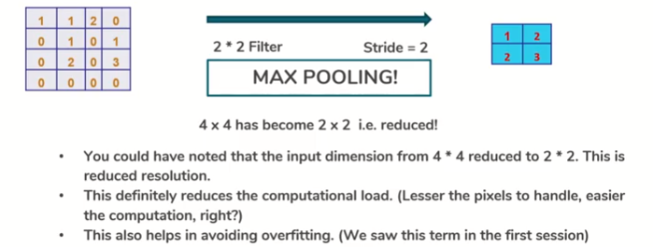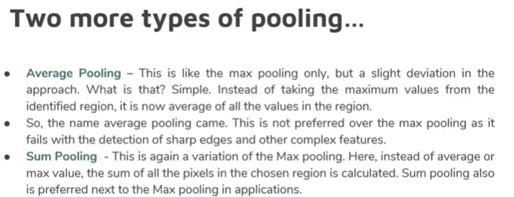

# CNN architecture

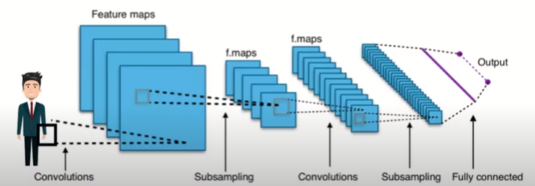

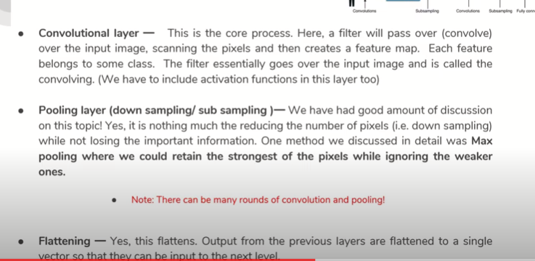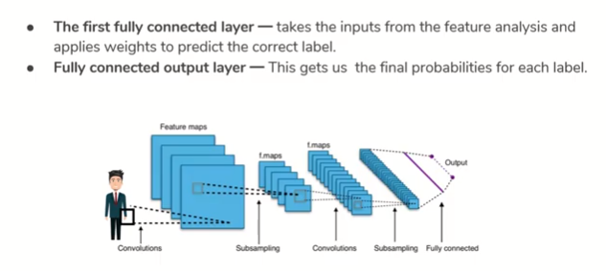

# CNN Types

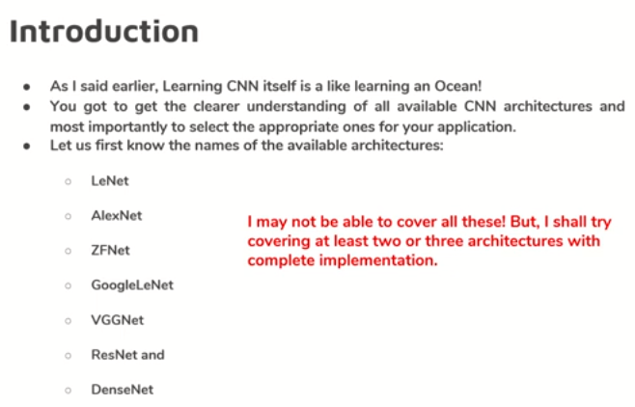

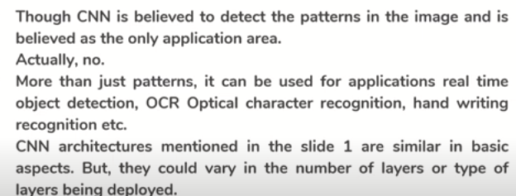

# LENET

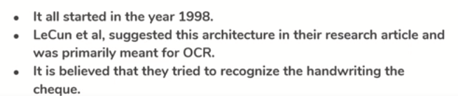

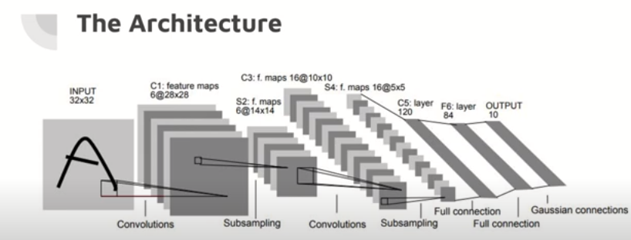

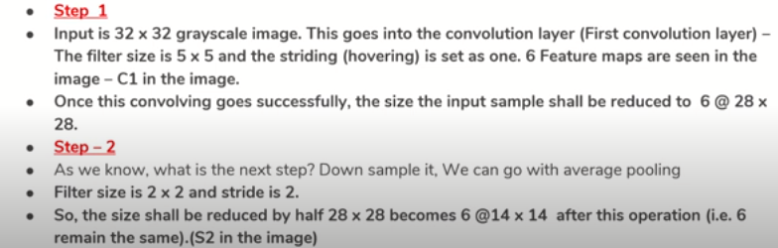

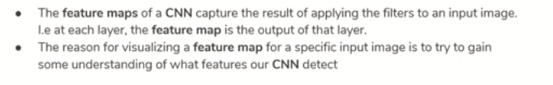

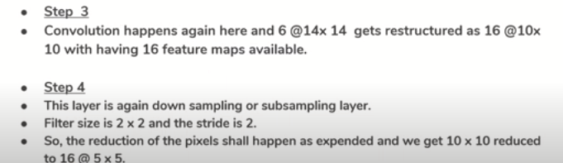

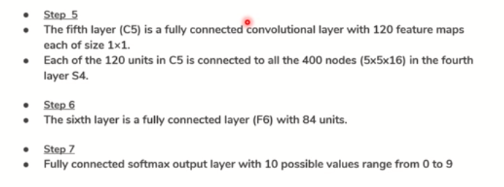

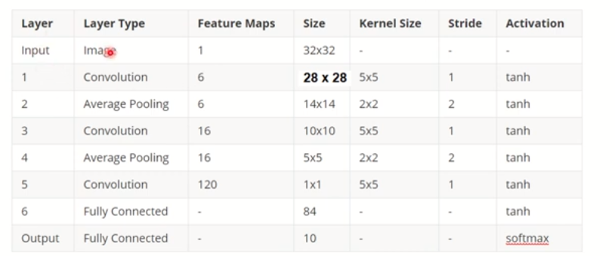

Kernel Size=Filter Size

# VGG16

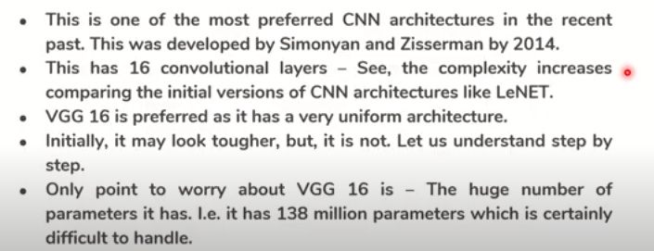

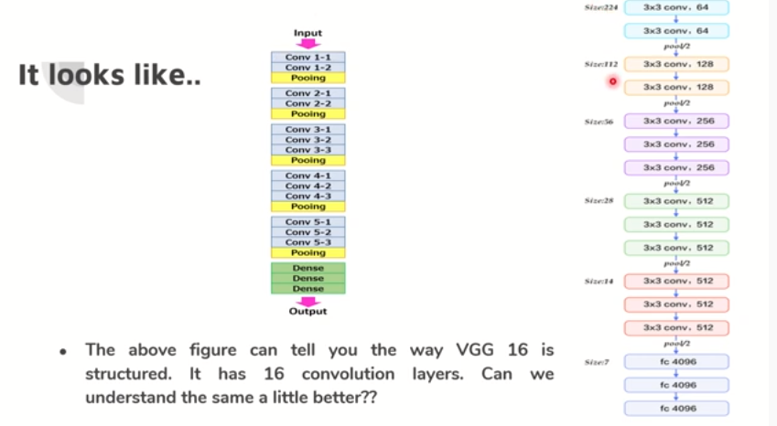

Pooling-Max Pooling

# Alex Net

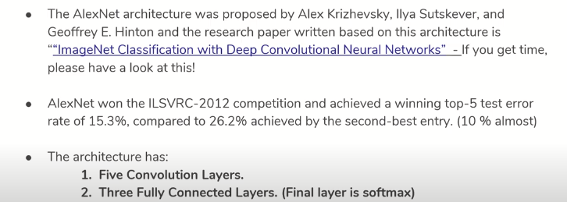

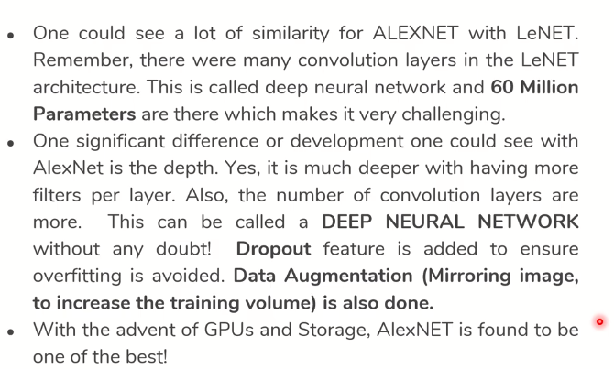

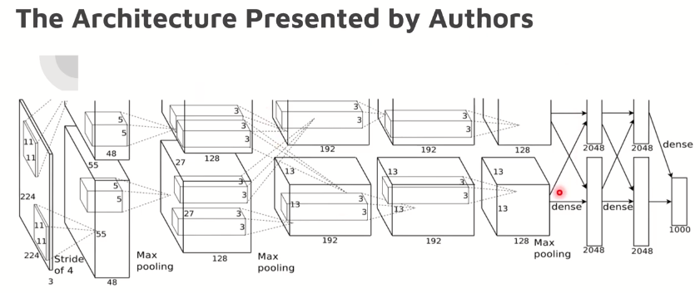

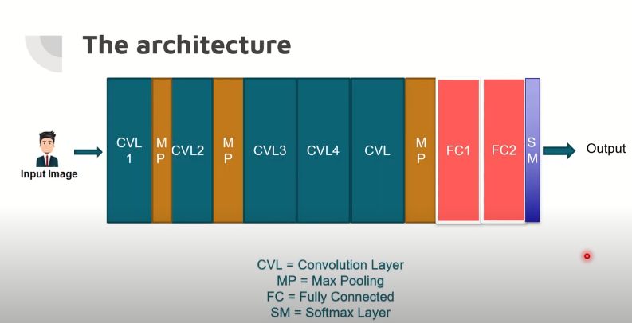

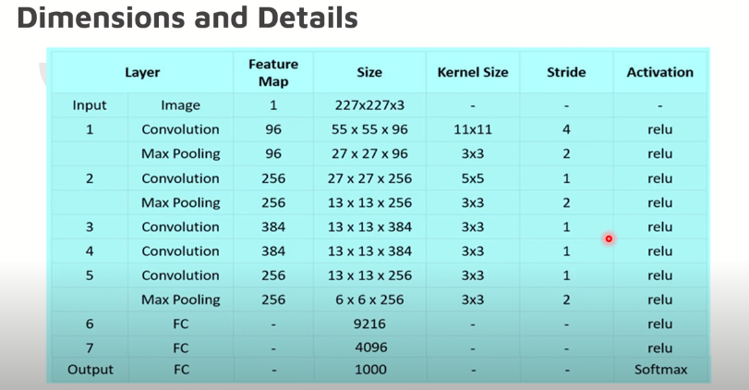

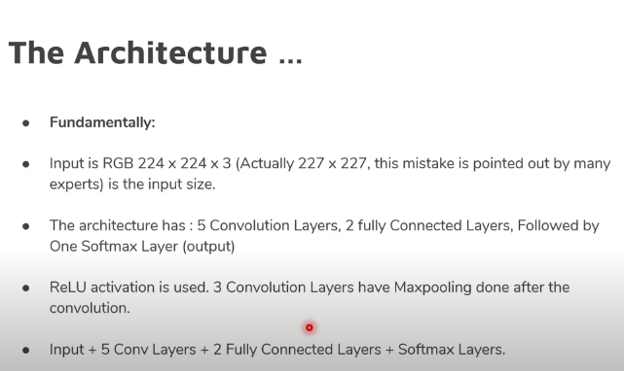

# Google Net

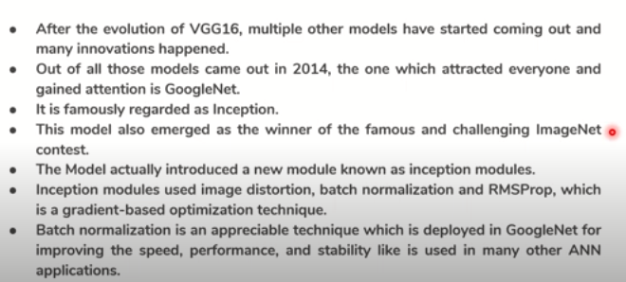

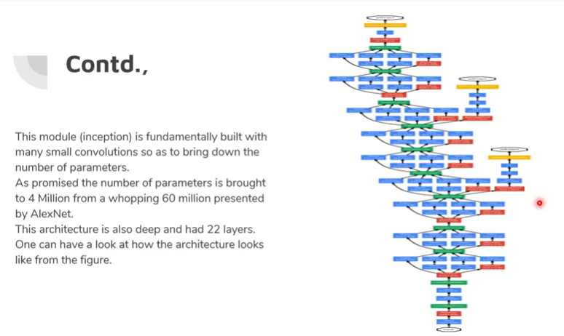

# Res Net

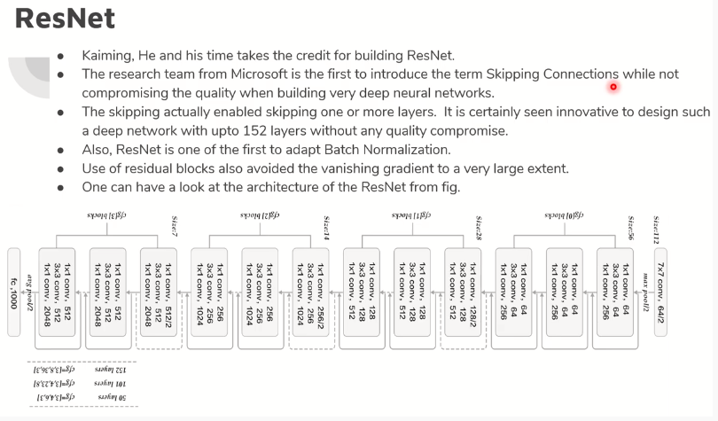

# ZF Net

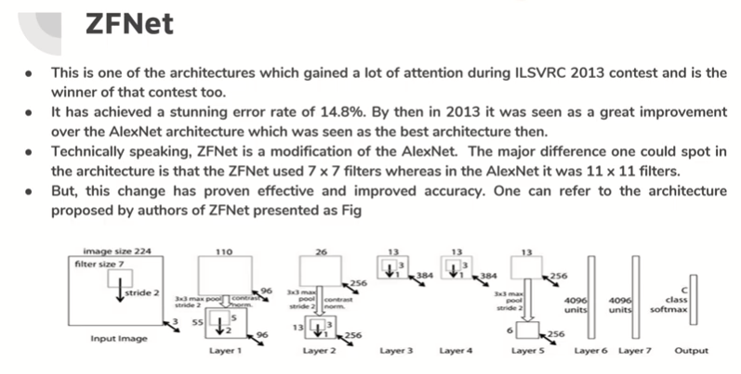

# Image Augmentation with Keras

* Image augmentation is a technique of applying different transformations to original images which results in multiple transformed copies of the same image. Each copy, however, is different from the other in certain aspects depending on the augmentation techniques you apply like shifting, rotating, flipping, etc.
* Applying these small amounts of variations on the original image does not change its target class but only provides a new perspective of capturing the object in real life. And so, we use it is quite often for building deep learning models.

[](https://cdn.analyticsvidhya.com/wp-content/uploads/2020/08/image-augmentation.png)

* These image augmentation techniques not only expand the size of your dataset but also incorporate a level of variation in the dataset which allows your model to generalize better on unseen data. Also, the model becomes more robust when it is trained on new, slightly altered images.
* Keras ImageDataGenerator class provides a quick and easy way to augment your images. It provides a host of different augmentation techniques like standardization, rotation, shifts, flips, brightness change, and many more.
* However, the main benefit of using the Keras ImageDataGenerator class is that it is designed to provide real-time data augmentation. Meaning it is generating augmented images on the fly while your model is still in the training stage.
* ImageDataGenerator class ensures that the model receives new variations of the images at each epoch. But it only returns the transformed images and does not add it to the original corpus of images. If it was, in fact, the case, then the model would be seeing the original images multiple times which would definitely overfit our model.
* Another advantage of ImageDataGenerator is that it requires lower memory usage. This is so because without using this class, we load all the images at once. But on using it, we are loading the images in batches which saves a lot of memory.
* Getting new images out of existing image

# Augmentation techniques with Keras ImageDataGenerator class

#### Random Rotations

* Image rotation is one of the widely used augmentation techniques and allows the model to become invariant to the orientation of the object.
* ImageDataGenerator class allows you to randomly rotate images through any degree between 0 and 360 by providing an integer value in the rotation_range argument.
* When the image is rotated, some pixels will move outside the image and leave an empty area that needs to be filled in. You can fill this in different ways like a constant value or nearest pixel values, etc. This is specified in the fill_mode argument and the default value is “nearest” which simply replaces the empty area with the nearest pixel values.

#### Random Shifts

* It may happen that the object may not always be in the center of the image. To overcome this problem we can shift the pixels of the image either horizontally or vertically; this is done by adding a certain constant value to all the pixels.
* ImageDataGenerator class has the argument height_shift_range for a vertical shift of image and width_shift_range for a horizontal shift of image. If the value is a float number, that would indicate the percentage of width or height of the image to shift. Otherwise, if it is an integer value then simply the width or height are shifted by those many pixel values.

#### Random Flips

* Flipping images is also a great augmentation technique and it makes sense to use it with a lot of different objects.
* ImageDataGenerator class has parameters horizontal_flip and vertical_flip  for flipping along the vertical or the horizontal axis. However, this technique should be according to the object in the image. For example, vertical flipping of a car would not be a sensible thing compared to doing it for a symmetrical object like football or something else

#### Random Brightness

* It randomly changes the brightness of the image. It is also a very useful augmentation technique because most of the time our object will not be under perfect lighting condition. So, it becomes imperative to train our model on images under different lighting conditions.
* Brightness can be controlled in the ImageDataGenrator class through the brightness_range argument. It accepts a list of two float values and picks a brightness shift value from that range. Values less than 1.0 darkens the image, whereas values above 1.0 brighten the image.

#### Random Zoom

* The zoom augmentation either randomly zooms in on the image or zooms out of the image.
* ImageDataGenerator class takes in a float value for zooming in the zoom_range argument. You could provide a list with two values specifying the lower and the upper limit. Else, if you specify a float value, then zoom will be done in the range [1-zoom_range,1+zoom_range].
* Any value smaller than 1 will zoom in on the image. Whereas any value greater than 1 will zoom out on the image.

**Image Data Generator methods**

So far we have seen how to augment images using ImageDataGenerator().flow() method. However, there are a few methods in the same class which are actually quite helpful and which implement augmentation on the fly.

#### 1. Flow_from_directory

The flow_from_directory() method allows you to read the images directly from the directory and augment them while the neural network model is learning on the training data.

The method expects that images belonging to different classes are present in different folders but are inside the same parent folder.

The following are few important parameters of this method:

* directory: this is the path to the parent folder which contains the subfolder for the different class images.
* target_size: Size of the input image.
* color_mode: Set to rgb for colored images otherwise grayscale if the images are black and white.
* batch_size: Size of the batches of data.
* class_mode: Set to binary is for 1-D binary labels whereas categorical is for 2-D one-hot encoded labels.
* seed: Set to reproduce the result.

#### 2. Flow_from_dataframe

The flow_from_dataframe() is another great method in the ImageDataGenerator class that allows you to directly augment images by reading its name and target value from a dataframe.

This comes very handily when you have all the images stored within the same folder.

This method also has a few parameters that need to be explained in brief:

1. dataframe: The Pandas DataFrame that contains the image names and target values.
2. directory: The path to the folder that contains all the images.
3. x_col: The column name in the DataFrame that has the image names.
4. y_col: The column name in the DataFrame that has the target values.
5. class_mode: Set to binary is for 1-D binary labels whereas categorical is for 2-D one-hot encoded labels.
6. target_size: Size of input images.
7. batch_size: Size of the batches of data.
8. seed: Set to reproduce the result.

**Keras Fit_ generator Method**

Right, you have created the iterators for augmenting the images. But how do you feed it to the neural network so that it can augment on the fly?

For that, all you need to do is feed the iterator as an input to the Keras fit_generator() method applied on the neural network model along with epochs, batch_size, and other important arguments. We will be using a Convolutional Neural Network(CNN) model. The fit_generator() method fits the model on data that is yielded batch-wise by a Python generator.

Let’s take a moment to understand the arguments of the fit_generator() method first before we start building our model.

* The first argument is the iterator for the train images that we get from the flow() or flow_from_dataframe() or flow_from_directory() method.
* Epochs are the number of forward/backward passes of the training data.
* Steps_per_epoch is an important argument. It specifies the number of batches of images that are in a single epoch. It is usually taken as the length of the original dataset divided by the batch size.
* Validation_data takes the validation dataset or the validation generator output from the generator method.
* Validation_steps is similar to steps_per_epoch, but for validation data. This can be used when you are augmenting the validation set images as well.

Note that this method might be removed in a future version of Keras. The Keras fit() method now supports generators and so we will be using the same to train our model.

**Model Building with Keras ImageDataGenerator**